How might we create a safer Baltimore for pedestrians and bicyclists?

MICA’s Center for Social Design + Maryland Department of Transportation Fall 2018 & Spring 2019

BACKGROUND

Pedestrians and cyclists represent over 20% of Maryland fatal traffic crashes (Maryland Bicycle and Pedestrian Master Plan, 2019 Update). In densely populated Baltimore City, pedestrians are often at risk, with crashes in Baltimore representing 30% of all statewide pedestrian crashes and 17% of all traffic-related pedestrian injuries (Baltimore City Transportation Safety Plan, 2015). One- third of pedestrian injuries are people under 19 years of age, and 60% of those involved are male.

PROJECT SCOPE

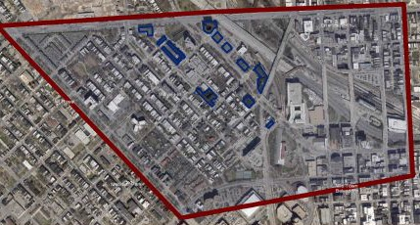In partnership with staff at Maryland Department of Transportation’s Motor Vehicle Administration Maryland Highway Safety Office, pedestrians, bicyclists, and other community stakeholders, MICA’s Center for Social Design will work to better understand the barriers to pedestrian and bicyclist safety in Baltimore and develop design prototypes with the ultimate goal of creating a safer Baltimore for pedestrians and bicyclists.

The project will focus on the areas immediately surrounding the MICA Campus (i.e., Bolton Hill, Mount Royal, and North Avenue).

ABOUT MICA’S CENTER FOR SOCIAL DESIGN
MICA’s Center for Social Design brings MICA students from a variety of disciplines together with outside partners from government, nonprofit and business sectors to identify opportunities, generate ideas, and make tools for positive social change. The center uses Human-Centered Design (HCD), a unique pathway to pursuing design interventions that are more informed by qualitative data.

The process includes multiple interwoven phases:

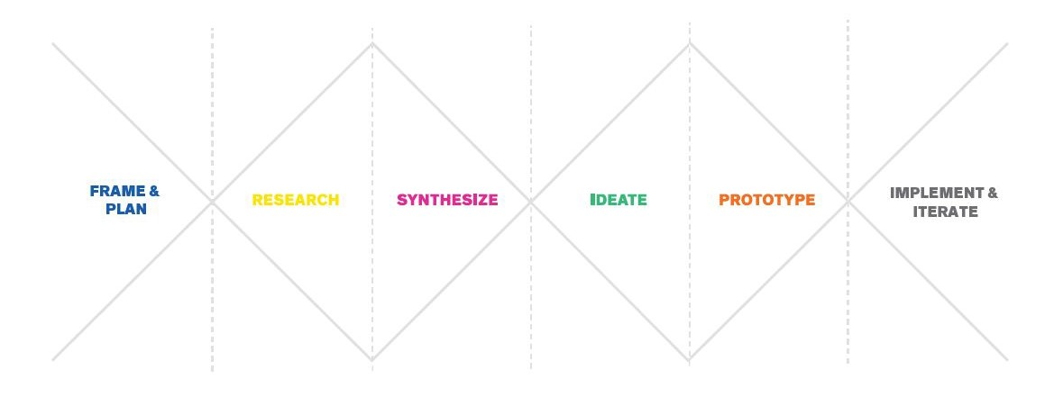
Frame & Plan: Students will organize existing scientific data and research associated with pedestrian and bicycle safety in the target area. They will facilitate discussions and create visualizations to better understand key data and research.
Research: Students will talk to, observe, and learn from Baltimore community members, neighborhood partner organizations, and other stakeholders to locate needs and assets.
Synthesize: Students will compile observations and research findings. They will create visualizations of key research and look for common themes and insights in order to identify appropriate opportunities for intervention.
Ideate: In collaboration with stakeholders, students will generate as many ideas as possible to address barriers to safety.
Prototype: Students will develop tangible representations of the ideas.
Implement & Iterate: In partnership with stakeholders and partners, students will pilot design interventions in multiple contexts and collect feedback.

JOIN US!
We invite you to design with us this fall! Meetings will be held at MICA’s Fred Lazarus IV Building, 131 W North Avenue, Room 175.
- Friday, November 9th, 10:30-12:00 pm: Research Shareback + Brainstorming Session
- Friday, December 14, 10:30-12:00 pm: Final Shareback

CONTACT INFORMATION

Becky Slogeris Kate McGrain
Associate Director, Center for Social Design Community Lead bslogeris@mica.edu kmcgrain@mica.edu
410.370.2079

